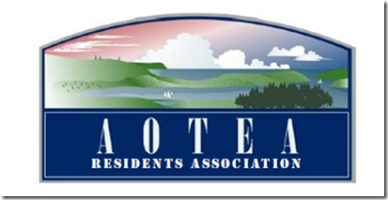

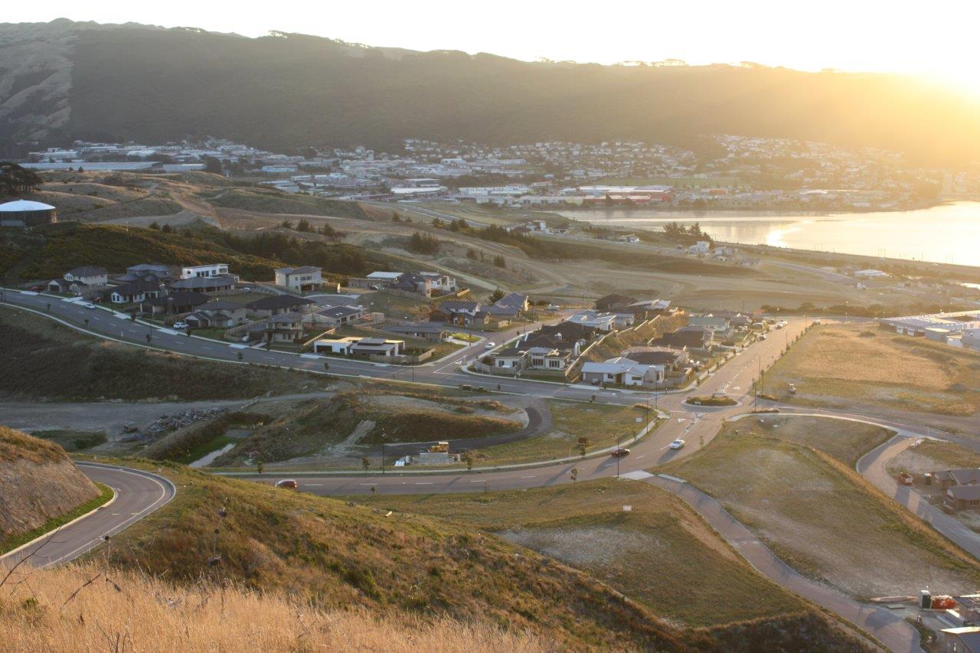

Village Plan 2015/16

# Introduction from the Aotea Residents’ Association

The Aotea Residents’ Association (‘ARA’) is pleased to present our inaugural village plan. As the newest suburb in Porirua city we have a unique opportunity within the city. Our suburb is still growing and changing, and as it does the needs and expectations of our residents’ change too.

The ARA was formed in 2013 by a group of residents who saw the need for a formal organization to support Aotea in creating an environment that reflected the needs of those that live here. Aotea is at an interesting point in its short history. Half of the suburb has been handed over to Porirua City Council for maintenance and potential development, while the other half is still under the control of Carrus, being the developers of the subdivision. Although we are new there are still challenges facing residents, such as inadequate street lighting, which are the same as other suburbs.

We have consulted extensively with Aotea residents while drafting this plan. It reflects the key things that residents see as priorities for Aotea. It is hoped that progressing with these initiatives will help Aotea develop into a community, rather than simply a collection of houses.

Rodney Strong  
Chairman  
Aotea Residents Association  
November 2014

ISBN 978-1-927291-40-5 (Print)  
ISBN 978-1-927291-41-2 (online)

# About Aotea

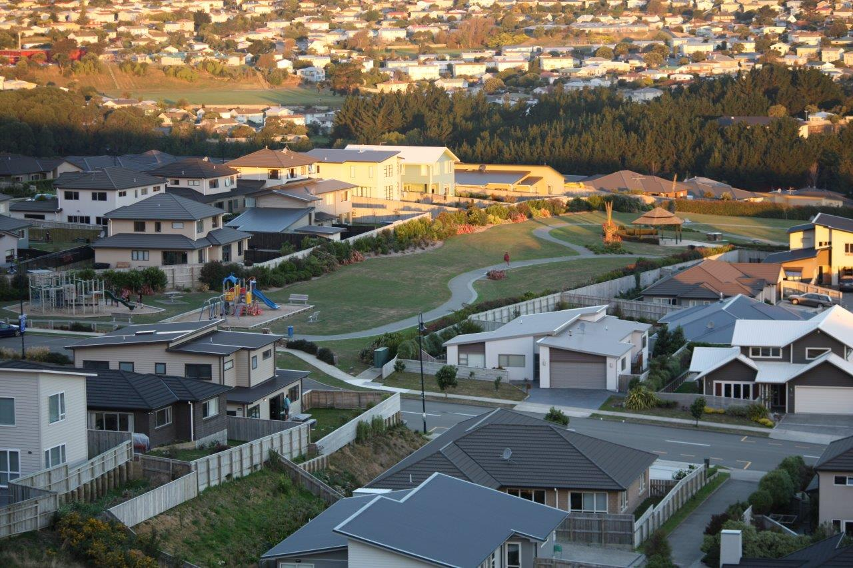The suburb of Aotea sits on the hills above Aotea Lagoon. The first houses were built in the late 1990s and development has been rapid since then. We currently have over 500 houses, two playgrounds, a retirement village, and a retail development.

Our population is diversely representative of many cultures and age groups. We have many families with small children, and equally a large number of retired couples. People are attracted to the area because of the close proximity to the motorway, allowing easy access to both Wellington and north to places like the Kapiti Coast, and the facilities available in the surrounding areas.

We have a Facebook group with over 500 members who use social media to discuss issues topical to Aotea, advertise local products, and find missing pets. For the last two years we have held a neighbours day event at Jasmine Underhill reserve. This is something the ARA would like to build on over the next few years, by introducing a range of events to cater for the diverse nature of our residents.

We are currently serviced by a retail development with four shops, although only two of those shops are currently tenanted. Charlies café has been open for just over a year, while House of Chic has been open for a similar time. A takeaway shop has been planned for several months, although at the time of this report an open date is still unknown. The fourth shop was originally set down as a dairy/four square. However the developers have had difficulty finding a tenant with the proposed Countdown supermarket being planned for Whitford Brown Avenue.

Also up on Whitford Brown Avenue is the Horouta marae. We are developing a relationship with the marae that will helpfully be beneficial to both them and the residents of Aotea. We have a number of home based business, ranging from cake tin hires, to a children’s party organiser.

# Residents wishlist

The types of improvements/changes that our residents would like to see can be split into two distinct categories. Maintenance and Development.

Maintenance involves things such as street lighting, rubbish bins, traffic calming, while development relates more to the types of things that residents consider are missing from Aotea.

## Maintenance

### Street lighting

Aotea was developed in a number of stages, beginning with stage 1 and currently up to stage 11. The street lights erected by Carrus in the earlier stages have proven to be highly susceptible to the strong winds that can sweep through Aotea. Several street lights have failed and been out of action for over a year. Since June 2014 the ARA has been liaising with PCC over this matter to try and get some momentum a resolution. We consider this to be a safety issue, with residents forced to walk down darkened streets, and feel that the council has not placed the correct amount of urgency over finding a solution.

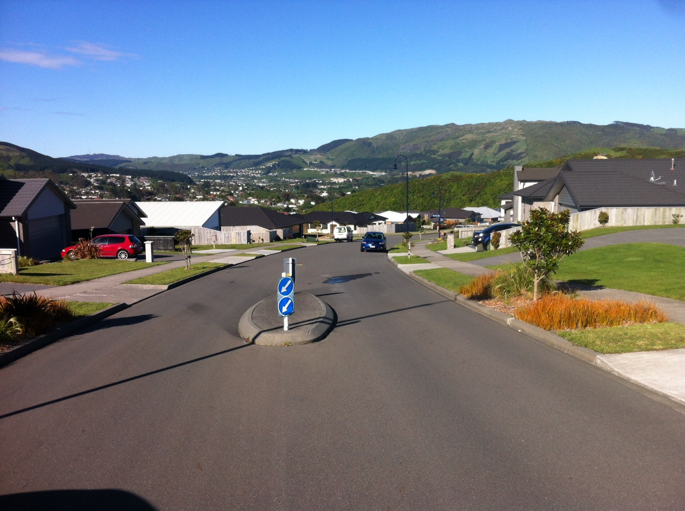**Deadline:** We would like to see a solution in place for all affected street lights.

### Traffic calming

Because roading was developed before the houses were built, in some cases this has meant that traffic calming features are poorly placed. Traffic safety issues have arisen where residents have been forced to go onto the wrong side of the road when exiting properties. Additionally there are instances where cars are forced into dangerous maneuvers due to parked cars either side of traffic islands. We look forward to working with the council to examine possible solutions.

In addition there are potential issues that have been identified at the bottom of Francis Brown Avenue where it connects with Okowai Road. Parking for Adrenaline forest can cause congestion at this corner which makes turning a potential problem.

There have been some concerns raised about the speed of drivers going up and down Francis Brown Avenue. This is quite a wide road that is still being built on and some drivers tend to exceed the speed limit. With the college right next to it, and people walking along the footpath there are potential dangers here.

**Deadline:** We would like to see all problem areas identified and solutions implemented.

### Bus Shelters

Aotea is on the local bus route, with several stops along Aotea Drive, continuing down Francis Brown Drive, and past Aotea College. Only one of the stops has a bus shelter. The rest of the stops are open to the elements. While this is generally not an issue there are some areas which would benefit from an actual shelter. In particular the bus stop directly opposite Aotea College, where pupils waiting for a bus are fully exposed to the wind and rain. Also the stop closest to Summerset Retirement Village. We would like to explore the potential for additional shelters.

Deadline: Hold discussions with the council and regional council, to explore options for sheltering some bus stops.

### Rubbish bins

In the interests of keeping Aotea clean and tidy we would like to see a public rubbish bin placed at the commercial development on Aotea Drive.

**Deadline:** Rubbish bin in place.

## Development

### Primary School

Currently the early stages of Aotea are zoned for Papakowhai primary school. The latter stages, including those still to be developed, are not zoned for any school. Schools are often seen as a focal point in a community and Aotea has a need and a desire to see a primary school built in our suburb. A school would provide additional facilities for residents, such as a school hall which could be used for community groups. Anecdotally we are aware that the lack of clarity around local schooling is causing concerns for potential home buyers/builders. While we don’t see a school as a right for a community, it seems strange that Aotea could be the only suburb within Porirua City without a primary school.

The ARA has held several discussions with the Ministry of Education on the possibility of a school and dialogue is ongoing. Carrus has indicated that there is some land available for the ministry should a positive decision be reached, and we will continue to press the ministry until a satisfactory solution is reached.

**Deadline:** It is difficult to set a deadline for this given that much of it is outside our control, however at the very least we would like a strong indication from the Ministry of Education of their intentions.

### Replanting

As part of the development of Aotea there was considerable removal of bushes, trees, etc. The vast majority of these were introduced species. Several areas within Aotea have been identified for replanting purposes and we would like to work with the council to ensure the appropriate level of input into the types of plants, trees that are planted. Given that most of these plants will take several years to grow into maturity it is important that the residents of Aotea take some responsibility for how their suburb will look for the next generation. We have already established a dialogue with the council in relation to this, and look forward to expanding on this as plans develop.

**Deadline:** We would like to work with Carrus and the council to establish a long-term plan for replanting throughout the existing and proposed stages.

### Aotea Lake

A third of the way down Whitford Brown Avenue is a small lagoon, hidden from the road by overgrown bush and weeds. Its existence is not widely known, but it is a potential asset to Aotea as a place to picnic or relax. However considerable work will need to be done to turn this into a true asset for Aotea, including clearing and replanting, and possibly some fencing.

**Deadline:** We would like to work with the council to redevelop this area.

### Recreational

While Aotea has two play areas, and a reserve with some exercise equipment and communal barbeques, there is a general lack of diverse recreational options within the suburb. Although Porirua has a large number of different outdoor options, it is important for our community to have locally based options for young and old. This could range from more walking tracks, to different things like an artificial playing surface. We will need to do more consultation with the community to narrow this down.

**Deadline:** We will work with Carrus, the council, and Aotea residents, to develop a plan.