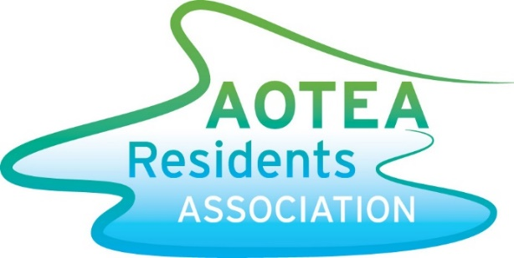

NEWSLETTER

Here we are almost a third of the way through the year, and what a fantastic start it has been weather wise. Although my lawn could have done with a bit more rain, my children were perfectly happy seeing sun every day.
It’s been a busy few months for the Residents Association. Last Sunday we had our annual Kids Day at Jasmine Underhill Reserve, which went very well. A special thanks to Kirsten Redshaw for her wonderful organization of this event. And a big thanks to all our sponsors.

Papakowhai School Rezoning
Most of Aotea is currently zoned for Papakowhai School, the exclusions being John Burke Drive and all roads off them. The school is essentially overflowing with students, and they can’t maintain that pressure while still providing a high level of education to children. As a result the school is looking to make some changes to their zone. It’s important to note they have indicated they are looking at small and sensible changes rather than wholesale changes. To help them make an informed decision, the ARA is collecting information on pre-schoolers. If you have any pre-school aged children can you please email us their ages and the street you are living in, as well as whether they have siblings already at Papakowhai School (note: we don’t need their names or your exact address if you are worried about providing the information). This will allow the school to get a better picture of what pupils are expected in future years from their current zone. Even if you are in the exclusion area please send the data, it all helps. Email it to aotearesidents@gmail.com by 21 March. (If you’ve already done this from the Facebook post then you don’t need to do it again).

Jasmine Underhill Reserve
The plans for making some changes to Jasmine Underhill have been confirmed. We are now awaiting final costs. The plan is for construction to start sometime before June this year. It is highly likely there will be a shortfall of funds, so we will be approaching local businesses with a view of sponsoring part of the improvements. If you know of any local business who might be interested please get them to email us. If you haven’t seen the plans, they are up on the noticeboard at the Aotea shops.

Aotea Reservoir
Wellington Water, in conjunction with Porirua City Council, are holding two open days at Aotea College in April to provide residents with information on the proposed water reservoir. This will sit up on the hill next to the existing reservoirs. The dates are 11 April, from 6pm-9pm, and 14 April, from 11am-3pm. Look out for a flyer in your mailbox with more information.
Regards
Rodney Strong (ARA Chair)

