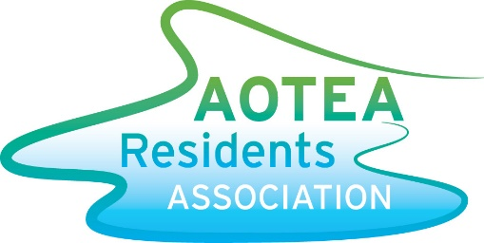
COMMUNITY CONSULTATION

Sunday 17th December
10.30am
Jasmine Underhill Reserve
As mentioned in a previous newsletter, the ARA received funds in the latest round of Porirua City Council Village Planning to go towards a revamp of Jasmine Underhill Reserve.
We’re holding a public consultation event to get feedback on the plans, and to take further suggestions from residents. This project looks at what we call stage 1, which is around the playground area at the top of the Reserve.
Staff from the Council will be present to answer questions, and there will be a display with the plans and concept drawings.
Don’t worry if you can’t make it, this is just the first step in the process and there will be other chances to contribute after Christmas.
And just because it’s holiday time, there will be a lolly scramble for the kids.
Hope to see you there, if not, have a wonderful summer.
Rodney Strong
Chair

COMMUNITY CONSULTATION

Sunday 17th December
10.30am
Jasmine Underhill Reserve
As mentioned in a previous newsletter, the ARA received funds in the latest round of Porirua City Council Village Planning to go towards a revamp of Jasmine Underhill Reserve.
We’re holding a public consultation event to get feedback on the plans, and to take further suggestions from residents. This project looks at what we call stage 1, which is around the playground area at the top of the Reserve.
Staff from the Council will be present to answer questions, and there will be a display with the plans and concept drawings.
Don’t worry if you can’t make it, this is just the first step in the process and there will be other chances to contribute after Christmas.
And just because it’s holiday time, there will be a lolly scramble for the kids.
Hope to see you there, if not, have a wonderful summer.
Rodney Strong
Chair

